University Ranking Solution

PROBLEM STATEMENT:
study ways to create a performance measurement solution to enable universities to
measure the quality of the education they deliver to their students. The approach will be to look into how an educational system in terms of faculty and courses contribute to the growth of their graduates over a 5-year period. You must figure out ways to track the jobs and promotions graduates get over time and assign rankings accordingly. In addition, track the connection of courses and their relevance to graduates' growth. One of your deliverables will be to design a dashboard that enables college and university administrators to compare the performance of their academic units. One important question, is to define your own ranking system of educational institutions especially for the developing world.
JAVA IMPLEMENTATION:
We will be building UI using java swing panels, for backend business logic we will implement using pojo class which are the identifiers for calculating the ranking system and it this system can calculated n number of university ranking which will help to compare which university over the period of 5 years is invaluable for the student success. We are also collecting feedback from companies and universities for the students.

ENTITIES:
University:
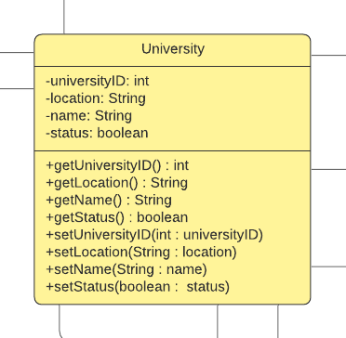

Attributes:
UniversityID: this variable will uniquely identify the universities.
Location: this variable will store university location.
Name: this variable will store value of university Name.
Status: this variable will store if university exists or not.

Methods:
getUniversityID: this method is used to retrieve get university ID.
getLocation: this method is used to retrieve university location
getName: this method is used to retrieve university names.
getStatus: this method is used to retrieve whether university exists or not.
setUniversityID: this method will set the university ID value.
setLocation: this method will set the university location.
setName: this method will set the name of the university
setStatus: this method will set the status of the university whether university exists or not.

STUDENT:
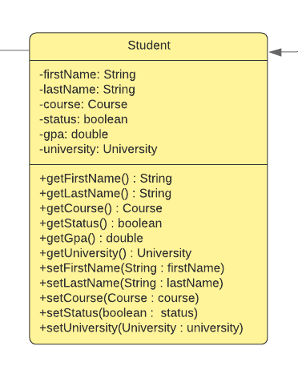
Attributes:
firstName: variable will store student first name
lastName: variable will store student last name
Course: object will store all values coming from course class
Status: status of a student whether he is alumni or existing student
Gpa: variable will store student GPA
University: university class objects will have all values from university class.

Methods:
getFirstName: this method will fetch firstName of the student
getLastName: this method will fetch lastName of the student
getStatus: this method will fetch status of the student whether he is active student or Alumni
getGPA: this method will fetch student GPA
getCourse: this method will fetch course object all value it is holding
getUniversity : this method will fetch university object all value it is holding
setFirstName: this method will set the student first name
setLastName: this method will set the student last name
setCourse: this method will set the course object value.
setStatus: this method will set status of student whether he is active student or alumni
setUniversity: this method will set the university object value.

FACULTY:
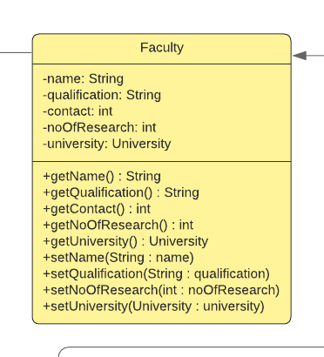
Attributes:
Name: variable will store faculty name
Qualification: this variable will store faculty qualification
Contact: this variable will store faculty contact number
noOfResearch: this variable will store faculty done how many number of researches
University: this object will store all information about university from university class

Methods:
getName: this method will fetch faculty name
getQualification: this method will fetch faculty qualification
getContact: this method will fetch faculty contact number
getNoOfResearch:this method will fetch the number of research done by faculty
getUniversity: this method will fetch university object values it holds
setName: this method will set the name of faculty
setQualification: this method will set the qualification of faculty
setContact: this method will set the contact number of a faculty
setNoOfResearch: this method will set the number of research done by the professor
setUniversity: this method will set the university object values it holds.

COURSE:
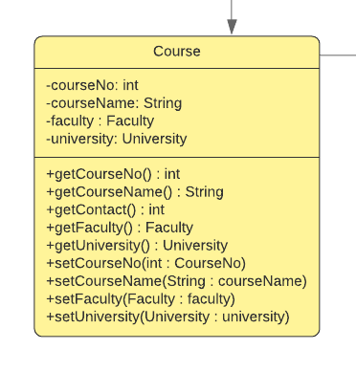

Attributes:
courseNo: this variable will store course number of a particular course
courseName: this variable will store course name
Faculty: this object will hold all values from Faculty class
University: this object will hold all values from University class

Methods:
getCourseNo: this method will fetch course number of a faculty
getCourseName: this method will fetch course name of a faculty
getContact: this method will fetch contact number of a faculty
getFaculty: this method will fetch all values object faculty hold
getUniverity: this method will fetch all values university object hold
setCourseNo: this method will set course number of a faculty
setCourseName: this method will set course name of a faculty
setFaculty: this method will set all the value of faculty object it holds
setUniversity: this method will set the value of the university object it holds.

COURSE OFFERING:
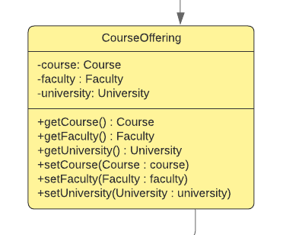
Attributes:
course: this object will hold all values from the course class
faculty: this object will hold all values from Faculty class
university: this object will hold all values from university class

Methods:
getFaculty: this method will fetch all values object faculty hold
getUniverity: this method will fetch all values which university object hold
getCourse: this method will fetch all the values which course object hold of course class
setFaculty: this method will set all the value of faculty object it holds
setUniversity: this method will set the university object.
setCourse : this method will set the course object value it holds from course class.

COMPANY:
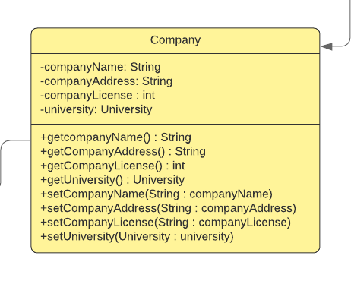
Attributes:
companyName: this variable will store the company name
companyAddress: this variable will store the company address value
companyLicense : this variable will store the company license value
university: this object will hold all values from university class

Methods:
getCompanyName : this method will fetch company name.
getCompanyAddress : this method will fetch the company Address
getCompanyLicense : this method will fetch the company license number
getUniverity: this method will fetch all values which university object hold
setCompanyName: this method will set the company name
setCompanyAddress: this method will set the company address
setCompanyLicense: this method will set company license.
setUniversity: this method will set the university object.

PLACEMENT:
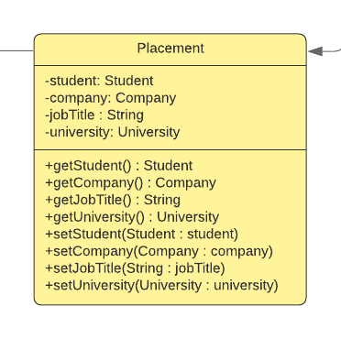

Attributes:
Student: this object will hold all the values from Student class.
Company: this object will hold all the values from company class
jobTitle: this variable will store value of jobTitle
University: this object will hold all values from university class

Methods:
getStudents: this method will fetch the student object values it hold from student class
getCompany: this method will fetch the all values from company class
getJobTitle: this method will fetch job title of a student for a company he is placed
getUniversity: this method will fetch the university object values it holds from university class
setStudent: this method will set the values from student class
setCompany: this method will set the all values from company class
setJobTitle: this method will set the job title for a student
setUniversity: this method will set the university object.

STUDENT EMPLOYMENT:
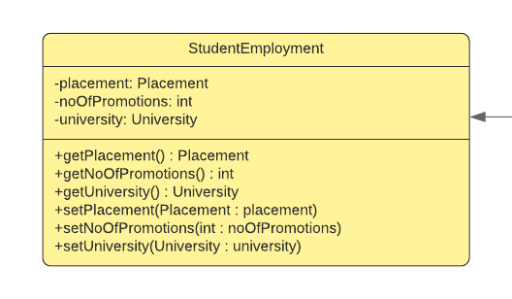
Attributes:
Placement: this object will hold all values from placement class
noOfPromotion: this variable will store number of promotion a student has received from the company he has joined
University: this object will hold all values from university class

Methods:
getPlacement: this method will fetch the value from placement object of placement class
getNoOfPromotions: this method will fetch number of promotions a student has received from the company he has joined.
getUniversity: this method will fetch the value from university object of university class
setPlacement: this method will set the placement object value it holds from placement class.
setNoOfPromotions: this method will set the number of promotions a student has received from the company he has joined.
setUniversity: this method will set the university object value it holds from university class.

RANKING:
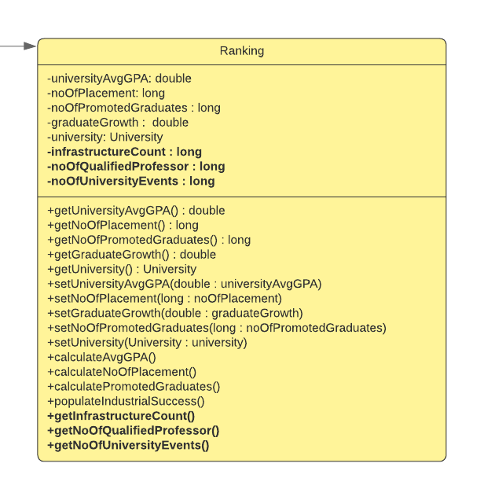

Attributes:
universityAvgGPA: this variable will store the value of university average GPA
noOfPlacement: this variable will store the value of number of placement happened in a particular university
noOfPromotedGraduates: this variable will store the value of number of promoted graduates in a company
graduateGrowth: this variable will store the value of number of students who has shown graduate growth
University: this object will hold all the values from University class.
infrastructureCount: this variable will store the value of number of infrastructure in the university
noOfQualifiedProfessor: this variable will store the value of number of qualified professor based on their highest qualification
noOfUniversityEvents: this variable will store the value of the number of events happening at the university.

Methods:
getUniversityAvgGPA: this method will fetch the university average gpa
getNoOfPlacement: this method will fetch the number of placement happened in the university
getNoOfPromotedGraduates: this method will fetch the number of promoted graduates in a company from a particular university.
getGraduateGrowth: this method will fetch the number of graduates who are growing in there career.
getUniversity: this method will fetch the all values from class university
setUniversityAvgGPA: this method will set the university average GPA
setNoOfPlacement:this method will set the number of placement happened in the university
setGraduateGrowth: this method will set the number of graduates who are growing in their career.
setNoPromotedGraduates: this method will set the number of promoted graduates in a company who belongs to a particular university
setUniversity: this method will set the all values from the class university.

Functional Methods:
calculateAvgGPA: this method will calculate average GPA of university based on all gpa of students
calculateNoOfPlacement: this method will calculate the total number of placement given by university to a student.
calculatePromotedGraduates: this method will calculate the total number of promoted graduates in a company who belong to same university
populateIndustrialSuccess: this method will calculate industrial success based on students who joined the company and are successfully placed in a company from university.
Extended Functionality:

getInfraStructureCount: this method will calculate the total infrastructure in a university.
getNoOfQualifiedProfessor: this method will calculate the total number of qualified professors in a university.
getNoOfUniversityEvents: this method will calculate total number events happening at the university.

EXTENDED UNIVERSITY MODEL:
OverView:
An object model showing the changes to the university model to support the new capabilities , the new capabilities which we have added are university events and infrastructure. These new capabilities will help to measure the performance of the particular university. Below two capabilities are explained.

Entities:
UNIVERSITY EVENTS
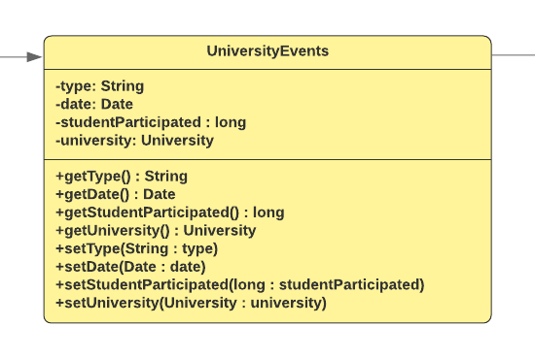
Attributes:
Type: this variable will store the event type happening at the university
Date: this variable will store the event date which has happened at the university
studentParticipated: this variable will store the number of students participating at the event.
University: this object will hold all the values coming from university class.

Methods:
getType: this method will fetch the event type at the university
getDate: this method will fetch the event date at the university
getStudentParticipated: this method will fetch the number of students participated at the event
getUniversity: this method will fetch all values from university class
setType: this method will set the event type at the university.
setDate: this method will set the event date at the university.
setStudentParticipated: this method will set the number of students participating at the university.
setUniversity: this method will set the value which is hold by university object of university class.

INFRASTRUCTURE:
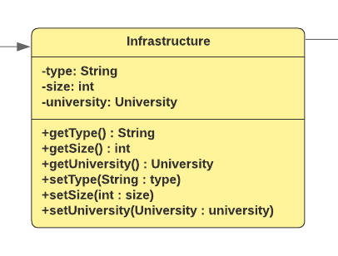
Attributes:
Type: this variable will store the type of infrastructure available at the university.
Size: this variable will store the size of the infrastructure at the university.
University: this object will hold all values from the university class.

Methods:
getType: this method will fetch the type of infrastructure available at the university.
getSize: this method will fetch the size of the infrastructure at the university.
getUniversity: this method will fetch the values from university object of class university.
setType: this method will set the type of infrastructure available at the university.
setSize: this method will set the size of the infrastructure
setUniversity: this method will set the values from university object of class university.

UNIVERSITY RANKING SOLUTION

Average GPA:
The average GPA is the major factor which helps in ranking the universities. This factor helps in determining how students are performing in their respective departments and is the major factor for scholarships.

Number of Placements:
This attribute helps to rank the university based on the number of placements which directly links to the GPA of the students.

Number of Promoted Graduates:
This attribute lists out the number of promoted graduates over a 5 year time within different companies which helps to determine how good the students are which directly related to university’s ranking.

Number of Industrial Success:
This attribute lists out the GPA ranges of the students and the number of students promoted within that GPA. This will be the important factor as this will be a deciding factor if GPA is directly related to industrial success or not.

Number of Infrastructure:
This attribute will list out the number of infrastructure the university has and how well is that maintained. This factor will help to determine the ranking of universities as more infrastructure will give ample opportunities to the students to excel in their career.

Number of qualified Professors
This attribute will list out the number of qualified professors at university. It is a general idea that more qualified professors will look to the universities with high ranking and hence this can also be an important factor in deciding university ranking.

Number of University Events:
This attribute defines how active the university is in organising events which include seminars, hackathons, career fair etc.

DASHBOARD

OBJECT MODEL

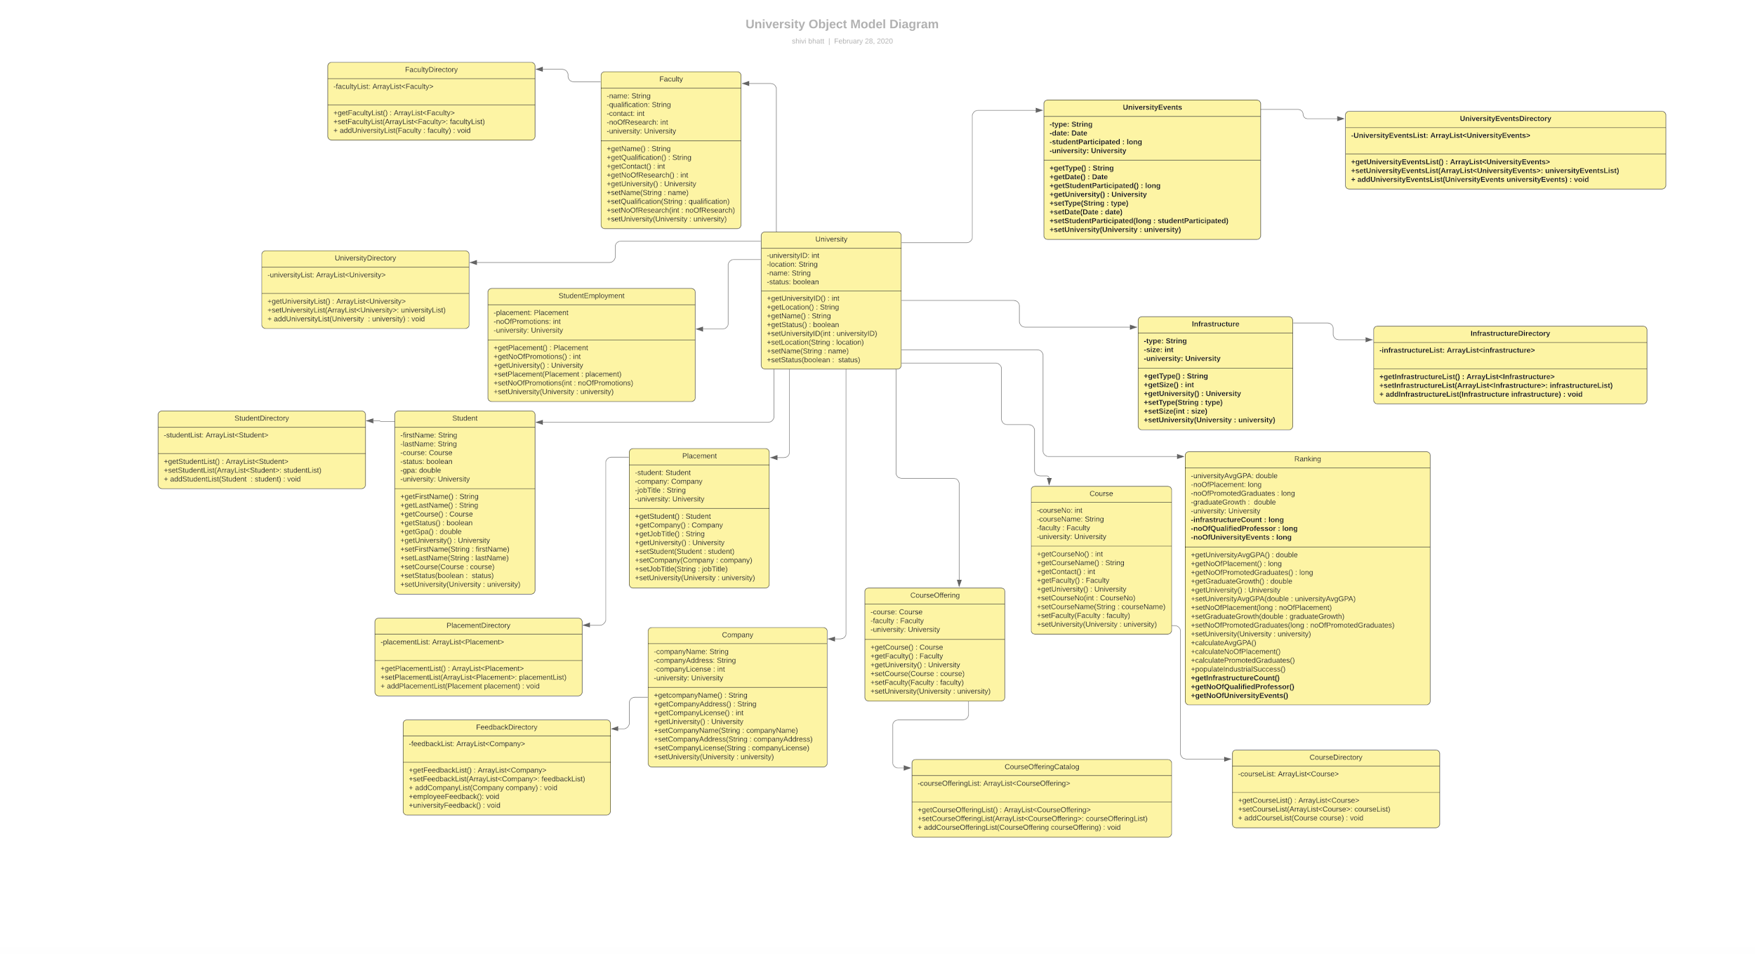

SEQUENCE DIAGRAM

